BIOSLAM

Craig Doyle
Technological University Dublin
TU819/4 Networking Applications
Dublin, Ireland
C19391816@mytudublin.ie

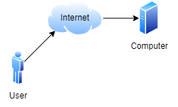
Fig.1. High Level Architecture [1]

Abstract—This project covers the process of reading bio-electrical signals and transporting these signals to an external device where they are processed. Actions are then performed according to the signal received.
Keywords—Bioelectricity, Wireless communication, Signal processing

Introduction
The objective of this project is to take various bio electric signals, transport, visualize & process them. This could be taking a measurement of eye movement and using it to manipulate a light switch in real time for example. The goal of this is to assist people with movement impairments to interact with their environment more easily.

Planning
Initially the focus of the project was mainly focused on how to transport pre-recorded signals to an external device for storage and analysis. However soon after this was achieved, I shifted focus to using real time signals.

Theory
Before planning the project, itself it was necessary to understand what exactly it was I was trying to store and analyze. What is being measured is the difference in voltage between two points on the body with reference to a ground point. How this works is that when a muscle or part of your body moves it creates a difference in voltage between the two points. I can then measure this difference and display it as a Line graph to understand more easily.
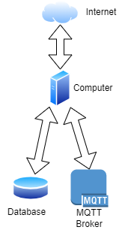
Fig.2. Flow of data in computer [2]

To analyze this data various methods were used such as peak detection to calculate someone’s heartrate or using thresholds to measure a muscle or ocular movement. Later in the project I came across issues due to signal noise, although this was eventually fixed in hardware, I investigated various software solutions for denoising the signal.

Infrastructure
The infrastructure for this project is made up of three parts.
The IOT device that is used to read the signals from the user’s body. The IOT device will then send the data over either internet or serial to another external device. This device will store and analyze the data. Then it can perform multiple actions based on this data. In figure 1 a high-level diagram of the structure for this setup can be observed.

The IOT infrastructure went through two iterations over the course of this project. Initially the IOT device used was an Arduino nano with a voltage amplifier that was used with some improvised leads. This iteration suffered from noise issues with the signal. I believed that the cause of this issue was the improvised leads used to take the measurement. In the second iteration of the device a premade PCB and manufactured leads were used to take the measurement. An ESP32 microcontroller was also used to allow for wireless communications from the IOT device.

The database chosen for this project was InfluxDB. This was chosen because it was a database that specialized in time series data. All data stored in the database is stored according to time. However, InfluxDB is not the only time series capable database available, another alternative is MYSQL or MariaDB which are both capable of storing time series data. The reason that using a time series database is so important is because the data is a measurement of voltage over a period.
The flow of data within the computer can be seen in figure 2. Originally a serial connection was used to transport the data from the IOT device to the computer, however I wanted a wireless solution for this. I considered multiple options including TCP or UDP. I decided against these options in favor of MQTT for two reasons. The first reason is that MQTT is easy to implement and already has multiple server implementations to choose from. The second is that the server or broker for MQTT allows for data to be uploaded and then sent to multiple clients in real time.
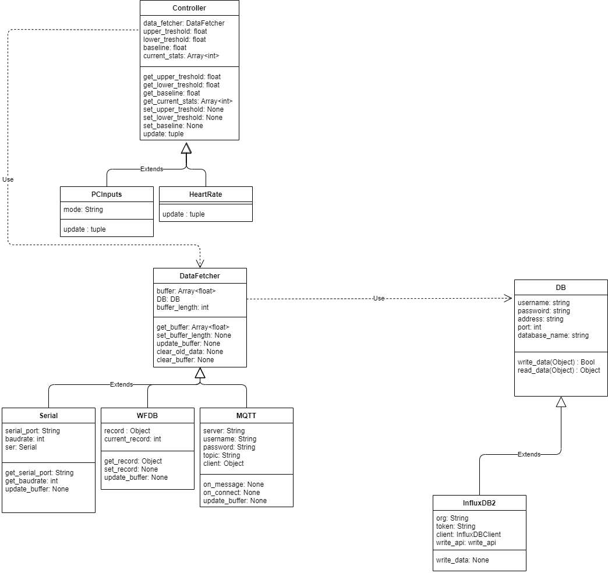
Fig.3. UML Class diagram for python code [3]

MQTT
One worry about using the MQTT protocol was that because of the extra overhead of using it, it may slow down the data transfer rate between the microcontroller and the broker. To test this, I made a quick program in rust that would send as many messages to the broker as possible in fifteen second bursts. The size of the data being carried in these bursts also varied.
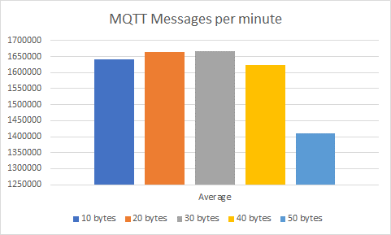
Fig.5. UML Class diagram for python code [5]
Figure 5 shows the number of messages sent to the broker measured in messages per minute at different data sizes. For the use case of this project, I can determine that this protocol will be sufficient as it is capable of sending / receiving more than one million messages per minute at the desired packet size.

However, the results of this can vary according to the hardware of both the MQTT broker as well as the client that is sending the messages. In this case I do not think that the IOT device will be capable of sending messages at these rates. I do think it will be sufficient to get a clear signal to the computer.

Code
There are three main sections of code in this project that will be discussed. The code for the microcontroller to take the measurements. The second is the python code on the computer, this code receives the data and then performs more actions based on the data received. The third piece of code is a bandwidth tester created for MQTT to ensure that it could transmit enough information in real time to fit my needs.

Python Program
The python program is made from three abstract classes. These classes perform the three core functions of the program. The first one is the entry point for data into the system. It takes data in and holds it in a buffer up until a period has passed. The next is the database class. This class is simply used to send a copy of any incoming data to a database for storage and later visualization if necessary. The final component of the program is the controller class. This class looks at the buffer and then performs actions based on that.

Each of these abstract classes contains methods and variables that build up a basic structure for what they are meant to be used for. This design decision was made to make the program modular and easy to modify. This can be seen with the data fetcher class. In figure 3 the UML diagram shows that it contains three subclasses. Each of these subclasses takes data in a different way. There is one for Serial communications, one for reading data from WFDB files and one for receiving data from an MQTT broker.

Figure 4 describes the flow of data visually when entering the python program. It enters the “DataIn” class, where it is then split to the database and the controller classes. From the controller class it then performed actions based on the data coming in and could also display the data to the user.

The Backend
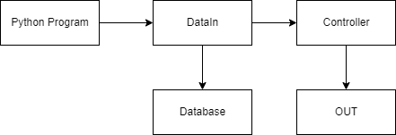
Fig.4. Flow of data in python [4]
For this project the backend or server architecture consists of two main components as seen in figure 2. The database of the user’s choice and the MQTT broker. I chose to use docker to host these services on the server. I chose to use docker for two main reasons, the first being that it would make the setup process easier and more concise. This means that it could be easily and quickly replicated on any machine. The second reason is that I could create a configuration file to install all necessary components for this.
There is another component that is in the server architecture, however it is not required by the code and only serves to make viewing past data easier. Grafana can be installed and used alongside the database to view past records that the code keeps.

While the database and Grafana are installed on the server using docker, the MQTT broker is not. This is due to difficulties getting the docker container for the broker to work properly and the added difficulty of managing the configuration files inside the container. The broker is installed natively on the server and is run using a system service.

Using the Template
After the text edit has been completed, the paper is ready for the template. Duplicate the template file by using the Save As command, and use the naming convention prescribed by your conference for the name of your paper. In this newly created file, highlight all of the contents and import your prepared text file. You are now ready to style your paper; use the scroll down window on the left of the MS Word Formatting toolbar.

Authors and Affiliations
The template is designed for, but not limited to, six authors. A minimum of one author is required for all conference articles. Author names should be listed starting from left to right and then moving down to the next line. This is the author sequence that will be used in future citations and by indexing services. Names should not be listed in columns nor group by affiliation. Please keep your affiliations as succinct as possible (for example, do not differentiate among departments of the same organization).

For papers with more than six authors: Add author names horizontally, moving to a third row if needed for more than 8 authors.

For papers with less than six authors: To change the default, adjust the template as follows.

Selection: Highlight all author and affiliation lines.

Change number of columns: Select the Columns icon from the MS Word Standard toolbar and then select the correct number of columns from the selection palette.

Deletion: Delete the author and affiliation lines for the extra authors.

Identify the Headings
Headings, or heads, are organizational devices that guide the reader through your paper. There are two types: component heads and text heads.
Component heads identify the different components of your paper and are not topically subordinate to each other. Examples include Acknowledgments and References and, for these, the correct style to use is “Heading 5”. Use “figure caption” for your Figure captions, and “table head” for your table title. Run-in heads, such as “Abstract”, will require you to apply a style (in this case, italic) in addition to the style provided by the drop down menu to differentiate the head from the text.
Text heads organize the topics on a relational, hierarchical basis. For example, the paper title is the primary text head because all subsequent material relates and elaborates on this one topic. If there are two or more sub-topics, the next level head (uppercase Roman numerals) should be used and, conversely, if there are not at least two sub-topics, then no subheads should be introduced. Styles named “Heading 1”, “Heading 2”, “Heading 3”, and “Heading 4” are prescribed.

Figures and Tables

Positioning Figures and Tables: Place figures and tables at the top and bottom of columns. Avoid placing them in the middle of columns. Large figures and tables may span across both columns. Figure captions should be below the figures; table heads should appear above the tables. Insert figures and tables after they are cited in the text. Use the abbreviation “Fig. 1”, even at the beginning of a sentence.
- Table Type Styles
Table Head | Table Column Head
Table Head | Table column subhead | Subhead | Subhead
copy | More table copyª
- Sample of a Table footnote. (Table footnote)
- Example of a figure caption. (figure caption)
Figure Labels: Use 8 point Times New Roman for Figure labels. Use words rather than symbols or abbreviations when writing Figure axis labels to avoid confusing the reader. As an example, write the quantity “Magnetization”, or “Magnetization, M”, not just “M”. If including units in the label, present them within parentheses. Do not label axes only with units. In the example, write “Magnetization (A/m)” or “Magnetization {A[m(1)]}”, not just “A/m”. Do not label axes with a ratio of quantities and units. For example, write “Temperature (K)”, not “Temperature/K”.

Acknowledgment (Heading 5)
The preferred spelling of the word “acknowledgment” in America is without an “e” after the “g”. Avoid the stilted expression “one of us (R. B. G.) thanks ...”. Instead, try “R. B. G. thanks...”. Put sponsor acknowledgments in the unnumbered footnote on the first page.

References
The template will number citations consecutively within brackets [1]. The sentence punctuation follows the bracket [2]. Refer simply to the reference number, as in [3]—do not use “Ref. [3]” or “reference [3]” except at the beginning of a sentence: “Reference [3] was the first ...”
Number footnotes separately in superscripts. Place the actual footnote at the bottom of the column in which it was cited. Do not put footnotes in the abstract or reference list. Use letters for table footnotes.
Unless there are six authors or more give all authors’ names; do not use “et al.”. Papers that have not been published, even if they have been submitted for publication, should be cited as “unpublished” [4]. Papers that have been accepted for publication should be cited as “in press” [5]. Capitalize only the first word in a paper title, except for proper nouns and element symbols.
For papers published in translation journals, please give the English citation first, followed by the original foreign-language citation [6].

Figure ..

